UNIVERSIDAD CENTRAL DE VENEZUELA
Doctorado en Economía
Cátedra Alberto Adriani

ECONOMIC RATIONALITY AND
POLITICAL BEHAVIOR ALLIES OR ADVERSARIES?

Prof. Dr. Luis Mata Mollejas (*
Dr. Dr. Kasim Asker Hasan (**)

(*) President of the National Academy of Economic Sciences of Venezuela and Coordinator of the Doctorate in Economics of the UCV, Caracas.
(**) Ambassador of the Republic of Iraq in Caracas and Cuba and Doctor and Post doctorate in Economics at UCV and Doctor in Engineering at the University of Aachen-Germany

Caracas, December, 2021

Introduction: Tensions in the Western Political Economic Order
The living things we call homo sapiens, they begin to leave significant traces from the Neolithic geolic era; 50,000 years ago. In the year 6,000 (a.C.) they begin to use calendars and clepsychras, to consider the march of time, and evaluate the opportunity to collect vegetables, fish and hunt; and sometime later, to start the activities of sowing, harvesting vegetables and breeding and benefiting animals; which makes the procurement of livelihoods less uncertain.
The subsequent aggregation of small settlements of permanent occupation (micropolis) occurs over the period from 2700 to 400 (a.C.); some 23 centuries, leaving traces found on the banks of the Euphrates, Tigris and Nile rivers, deserts of governments of nearby territories (two days of pedestrian march) dedicated to agriculture... controlled spaces that history calls Ancient Empires.
Between 378 (a.C.) and 1453 (d.C.) (19 centuries) at the apex of the meeting between the continents of Europe, Asia and Africa, history places the Greek, Roman-Byzantine civilizations, and calls "Middle Ages" the period from the tenth to the fifteenth century (d.C.); and the latter he calls "Century of Lights or Renaissance", highlighting the persistence of ideas and customs initiated in Ancient Greece and in "Imperial Rome" that governed the traffic of goods and people in the territory located on the shores of the Mediterranean, Black and Red Seas.
During the period of the XVI and XVIII century, "Mercantile Empires" were constituted; that extend their influence over all planetary lands and seas; including the American continent, the African continent, the Atlantic Ocean, the large islands of the Indian and Pacific Oceans, and the coasts of Southeast Asia.
The "Mercantile Empires", governed from Europe, use as a means of payment for their commercial transactions and the suffrage of their military confrontations, sustaining economic dominance; instrument called "commodity money", for consisting of "silver-gold coins, with an average exchange ratio between them of "15 to 1"; according to practice and norms, created during the first century of the Christian eras; including the granting of loans, in metallic coins, at an average interest rate of 1% per month.
Subsequent modifications, in the XVII century, of the aforementioned norms, include the acceptance and circulation of "fiduciary scriptural" money; facilitating the increased credit; issue that we call step of the First Generation to Second Generation Finance, from the creation of the Bank of England (1694) process that operates until 1972; although with the move of the political center of control to Washington-New York, in the period 1945-1972; with rules agreed at Bretton Woods, at the end of World War II (1938-1945) that set the price of monetary gold at $35 a troy ounce.
Let us emphasize that political tensions, arising from the pragmatic privilege (not legal) granted to Washington to issue credit obligations to its treasury, according to its political purposes, although it makes flexible the offer of international liquidity, geopolitically disadvantages the rest of the economies; whose fiscal conduct must monitor the solvency of the national treasury, so as not to depreciate the exchange rate of their currencies against the US dollar.
Say in passant, that such a privilege became increasingly reprehensible, when the PRICE in US$ of oil, rises, with the exception of the United States,... being the issuer of the international monetary standard. A circumstance openly denounced by French President Mitterrand, when speaking of the "dollar-oil pincer" exercised by Washington since its agreement, with Saudi Arabia, to continue charging the price of oil in US$.
We must, then, review Figure No. 1 relating to interaction between the occupation of planetary space, to the political and economic constraints of the financing the production and distribution of goods, and to the cognitive synthesis that sustain them; including the social relations of economic political actors and the use of the instruments used, as an analytical basis to appreciate the dynamics of the interaction between economic rationality and political conduct and characterize the circumstances present at the beginning of the XXI century; using, as basic information, the factual content of Table No. 1 that we call: Cosmogonic Synthesis of Homo Sapiens.

Scheme No. 1
Elements of the cosmogonic dynamics of homo sapiens

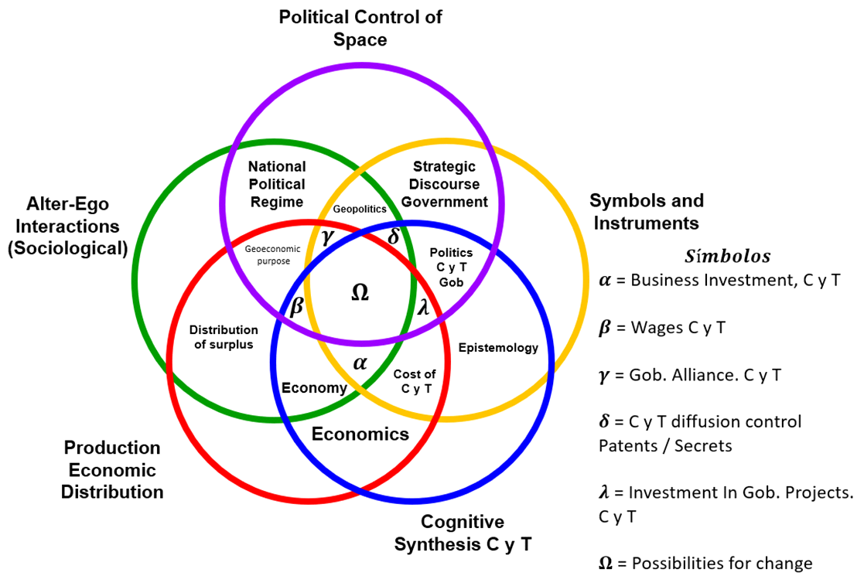

The referred scheme (No. 1) shows, how, dual interactions the distribution of the economic surplus; the existing political regime; the government's strategic discourse presented to civil society; the epistemology that defends this discourse and the admitted economic theory or Economics.
The triple interactions they are: the political economic aspirations of civil society; the geopolitical practice (including alliances) of the government; (C) the government's support for the processes of scientific and technological creation and (E) the budgetary contributions for it.
These elements give the following results: (ɤ) the investment of private companies in C and T; (β) wages relating to the activities of C and T; (ϒ) national and foreign alliances in C and T (δ) the rules for the protection of patents and State "secrets" and (λ) investment in public institutions of C and T, plus "assistance" to private ones: direct subsidies/tax exemption; and finally, the quintuple interaction yields the diagnosis situational of the Nation State under study.

TABLE No. 1
Cosmogonic Synthesis of Homo sapiens
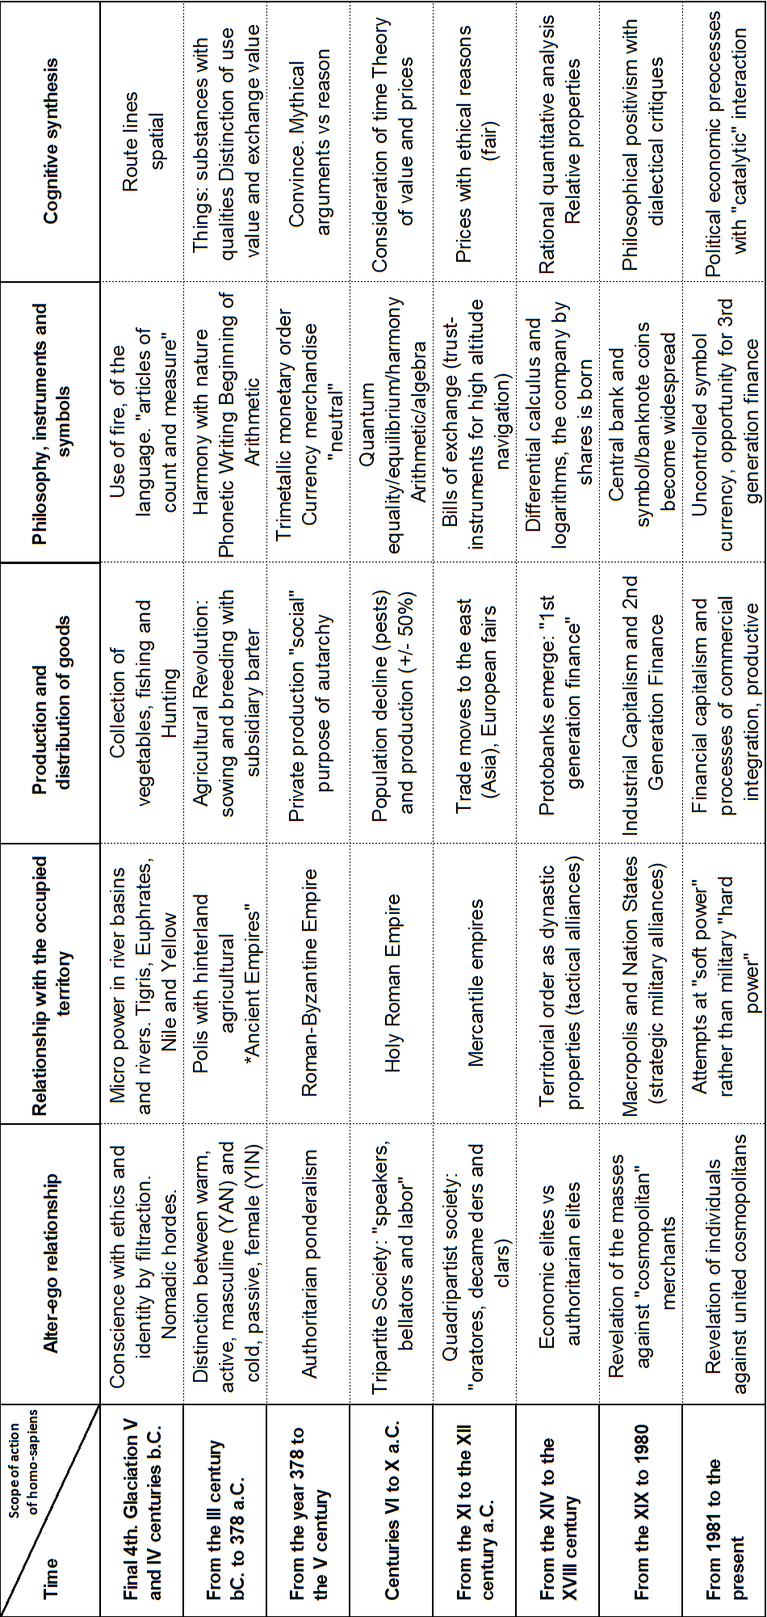

Being able to conclude, from the scheme No. 1, in a very tight synthesis:
- That human decisions have logical-philosophical components aimed, on the one hand, at minimizing the uncertainty that comes from the attempt to take advantage of the physical material environment (resources and spaces); with criteria of Maximin in relation to benefits and Minimax in relation to costs; or rational options from the angle of the economy;
- That the set of habits behavioural-political, Decanted over time for the use of resources in the occupied habitat, or cultural heritage, forms a benchmark of political conduct and,
- That decisions to act (use of will) or exercise of politics by combining the above elements (economic and political/cultural) provide the basis for a vision of assembly purpose: global or strategy content of procedures by activity, or explanations Tactics.
Owing then that the economy provides options for conduct, so that the policy chooses between them: being the ex post result of the selected strategy subject to the judgment of civil society, according to the balance between its purposes; being able then require further economic/political analysis in sequence: condition that has been called "porosity", which we interpret as catalytic influence between politics and economics; issue that we discuss below.

- The dynamics experienced up to the present
According to the specialized literature, the first attempt to combine "Economics" with inherited political pragmatics: authoritarianism, was "mercantilism" or "metallic cris hedonism"; that gave priority to the conservation, in the country, of the stocks of commodity currency, to pay the armies and acquire abroad what the national space could not produce, for reasons of human capacity or of non-existence of the necessary natural resources.
A decisive element of the abandonment of mercantilist doctrine was the concern about the increasing depletion of potential silver/gold miners, and the need for fiat currency, given the fiscal unsustainability of operating with metallic currency.
The substitute thought was that of the physiocracy; which postulates that the true source of wealth was the net surplus of agriculture. But such a doctrine paid no attention to industrial production and value added by transforming "natural" products into "commodities", which require credit. Hence the substitution of physiocratic practices for those of the liberal capitalism based on the compensation of monetary flows with real flows situation called equilibrium by association with the notion of equilibrium in physics.
Thus, from the end of the XVII century, political action suppressed inherited regulations, in the markets of goods and labor, and imagined and promoted a private banking order (provider of credit), assisted by a Central Bank of the State, so as not to alter the usual valuation between gold and silver coins, by replacing, part of the monetary flows, by flows of "fiat currency" (Central Bank notes).
In the course of the XVII and XIX centuries it was criticized, the new economic order was severely criticized; the worker was believed to be "robbed and exploited". The theoretical discussion between the "Hegelian Marxist" critics and the Vienna School clarified that the "theft" of the wage earner it was not possible, since he received his salary, before the produced merchandise was sold.
The solution of the critics (Marxist-Leninists) was to delegate to the state the decisions of all economic processes including a subsistence wage. Such an experience, begun in 1917 with the creation of the USSR, ended, in 1989, in flagrant political-economic implosion; provoked by opposing the "I want" of the individual of Civil Society, the government self-identification with the social whole: "the people"; minimizing the possibility of personal self-fulfillment; as argued by Nietzsche (1881), Hayeck (1946) and Erhard (1957).
The doctrinal solution we propose and the consequent political practice are given by the "financial capitalism"; by promoting the distribution with continuous ex ante trading, of the economic surplus (measured by the yield (q) provided by the stock exchanges among all economic actors: entrepreneurs, workers and bankers; considering the interaction between the exchange rate (ch) defined in the foreign exchange market and the rate of updating of securities on the Stock Exchanges... close to the interest rates of the Central Bank (rf).
We should warn that a critical political point of attention is that the scope of action of financial leadership is planetary... without stable attachment to any nation state.
This requires an evaluation of the defense capacity/possibility of the share capital (R. de Vries, 2004) on the board of the spheres of power (Held: 1997) by making explicit, in each Nation State, the conditions of governance (Focault) in studying the desirability and possibility (real politik) of institutionalizing Third Generation Finance (Mata, Hasker: 2018).
To this end, it is appropriate to recall that the theoretical contributions related to social complexity include, notably, the authors cited in the Scheme No. 2, whose ideas allow to evaluate, objectively, the possibilities of transformation/social change by considering (here and now) as interactions: dual, triple, quadruple and quintuple, between the Sets of variables of the: Philosophy and History; of the Economy and Administration; of the Politics and Sociology; and the Psychology and Anthropology, considered key by recognized authors of the XX-XXI centuries in the performance of the macro processes of geo politics and geoeconology (See scheme No. 3).
- The survival of organizations; 2) individual survival; 3) the influence of leadership; 4) the "hard" aspirations of the "Masses" and 5) the influence of external conditioning factors (environment).

Scheme No. 2
Relevant Authors of Social Complexity

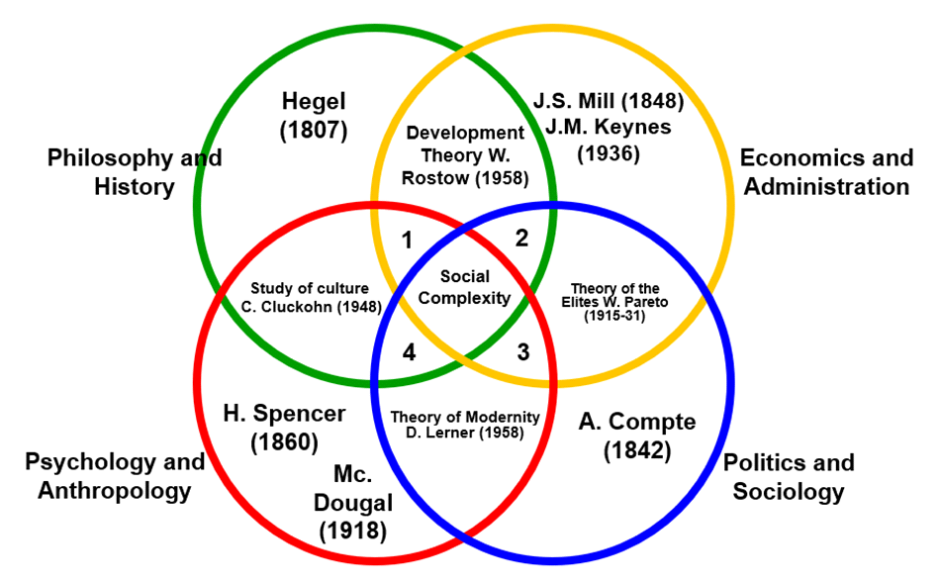

Scheme No. 3
Elements of the dynamics of Organizations

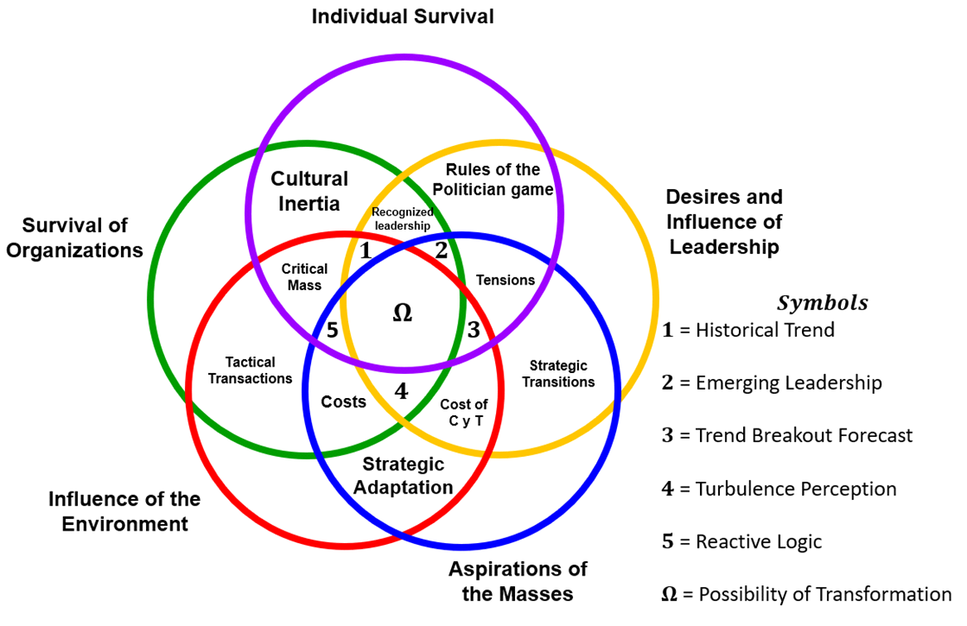

III) Final comments
Let us recognize that the choices offered by economic science or "economics" are essentially "tactical" and that policies are "strategic" and that the desire of governments to preserve "forever" ideological decisions finds "always", a strong political conditioning, when the aspirations of material progress of Civil Society do not materialize.
Politically critical issue, as government schizophrenia, a sufficient cause of persistent civil dissatisfaction, provokes Turbulence, capable of exacerbating the search, by Civil Society, of allies in the emerging leadership, at the national military level, and between the international actors, affected by the symptomatology of deterioration (the breakdown of trends) associated with payments not made, due to fiscal fragility or bank insolvency... key triggers of the reactive logic, propitiating electoral failures, coups d'Etats, and foreign sanctions, by effectively operating the conditions set forth in Scheme No. 3.

BIBLIOGRAPHY
ATTALI, J. (1981): Les trois mondes. Edit. Fayard, Paris
BREMMER, I. (2007): The J. Edit Curve. Ateneo, Buenos Aires
CANETTI, E. (1997): Mass and Power. Edit. Muchmik, Barcelona
CARRILLO BATALLA, T.E. (1989): The great contributions to the History of History. Edit. National Academy of History. Bulletin No. 987, Caracas
CASSIRER, E. (1955): The Science of Culture, F.C.E. Mexico
GARDNER, R.N. (1974): The Hard Road to World Order Foreign Affairs. Vol. 52 No. 3
GREENSPAN, TO. (2008): The Age of Turbulence. Ediciones B.S.A. Barcelona
HALL, R. (1977): Organizations, Structure and Process. Edit. Prentice Hall, New Jersey
HEGEL, G.W. (1927): Lessons on the Philosophy of History.
KRUGMAN, P.R. (1997): Currency Crisis. Edit. Norma, Bogota
LANDMAN, M. (1961): Philosophical Anthropology. Edit. UTEHA, Mexico
MATA MOLLEJAS, l. (2018): Of Capitalisms and Socialisms. Edit. Alberto Adriani Foundation. Caracas
__________________ (2017): Consequences of Neo-Imperialism. Edit. Alberto Adriani Foundation. Caracas
__________________ (2006): Symbolic Logic and Formalization of Hypotheses in Social Sciences. Reread No. 23. (Cipost/UCV) Caracas
MORAD, S.A. and I. Silverschimdt: (2010): La Vérité sur la Crise. Editions Leo Scheer. Clamecy, France.
SALBUCHI, TO. (2007): The Brain of the World. Editions of the Copyist. Cordoba, Argentina
STIGLITZ, J. (2010): Free Fall. Santillana Editores (Taurus). Madrid/Mexico

